High Performance UHF RFID Module

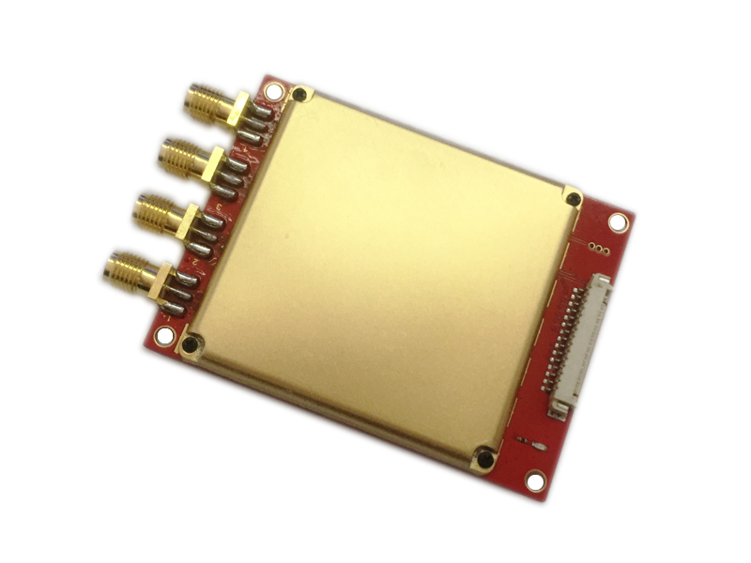

Model: CF-MU804
Size: 67.5mmx51mmx7.9mm

GENERAL DESCRIPTION
CF-MU804 is a high performance UHF RFID Module. It is designed upon fully self-intellectual property. Based on proprietary efficient digital signal processing algorithm, it supports fast tag read/write operation with high identification rate. It can be widely applied in many RFID application systems such as logistics, access control, and industrial production process control system.
FEATURES
- Self-intellectual property;
- Support ISO18000-6C(EPC C1G2) , ISO18000-6B protocol tag;
- 865~868MHz/902~928MHz frequency band(frequency customization optional);
- FHSS or Fix Frequency transmission with RF output power up to 33dbm(adjustable);
- Effective distance up to 9m (with external 6dbiL antenna and tag E41);
- Support RSSI;
- Maximum inventory speed over 700pcs/s;
- Tag buffer size up to 1000PCS@96bits EPC;
- 4 SMA antenna port with antenna failure detection;
- Low power dissipation with single +3.7~5VDC power supply;
- Support 4 GPIOs (2 input and 2 outputs);
- Support RS232 (3.3V TTL level);
- High reliability design;
- Support on-the-site firmware upgrading.
CHARACTERISTICS
- Absolute Maximum Rating
ITEM | SYMBOL | VALUE | UNIT
Power Supply | VCC | 5.5 | V
Operating Temp. | T_{OPR} | -20~+55 | ℃
Storage Temp. | T_{STR} | -20~+85 | ℃
- Electrical and Mechanical Specification
Under T_{A}＝25℃，VCC＝+5V unless specified
ITEM | SYMBOL | MIN | TYP | MAX | UNIT
Power Supply | VCC | 3.7 | 5 | 5.25 | V
Current Dissipation | IC |  |  | 1500 | mA
Frequency | F_{REQ} | 860 |  | 960 | MHz
RF Output Power | P_{RF} | 0 |  | 33 | dBm
RF Power Accuracy | AP_{RF} |  | +/-1 |  | dBm
RF Power Flatness | FP_{RF} |  | +/-0.2 |  | dBm
Receive Sensitivity | SR |  | -85 |  | dBm
Size | Size |  | 67.5 x 51 x 7.9 |  | Mm
MECHANICAL DATA(UNIT mm)：

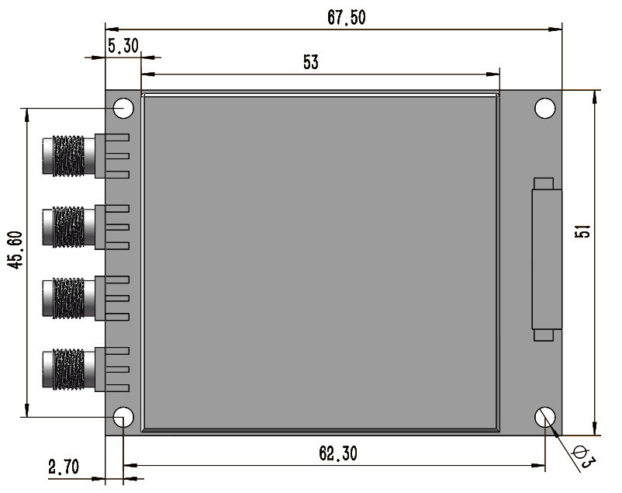
Pic.1 Module Size and Fixing Hole Location

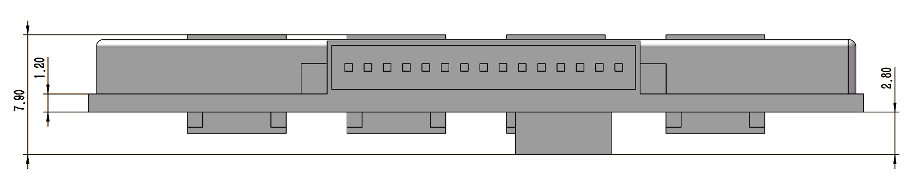
Pic.2 Module Thickness
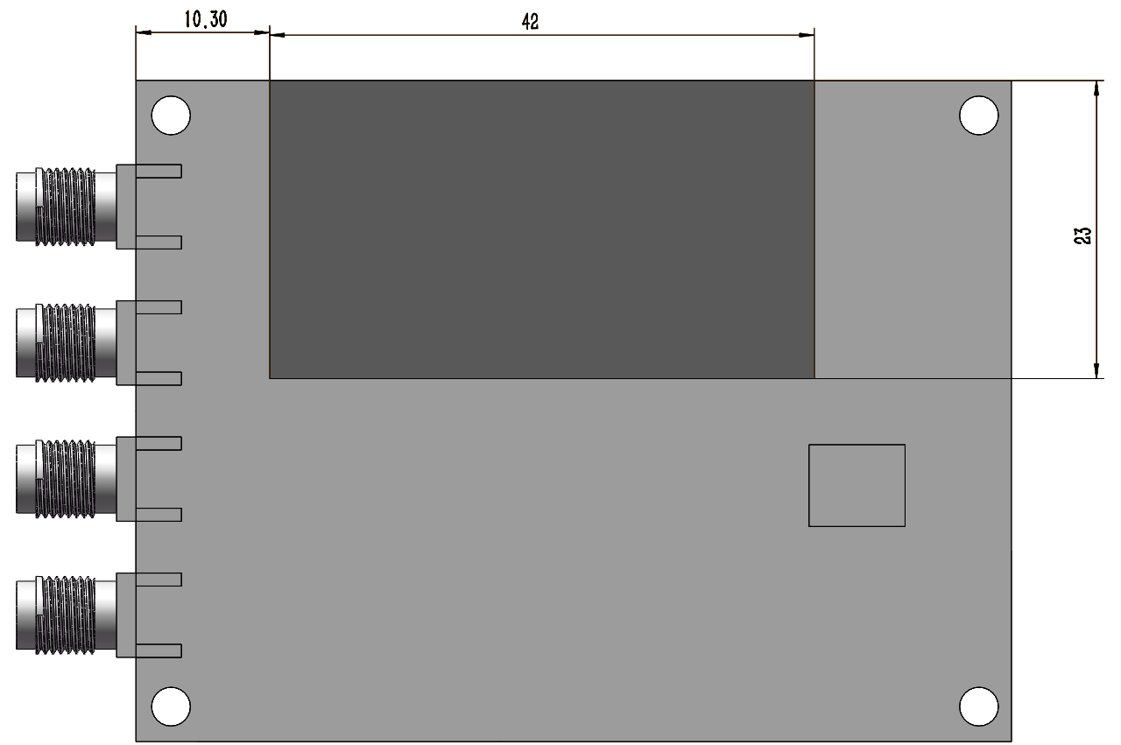
Pic.3 Heat Sinking Area
INTERFACE
- Host Interface

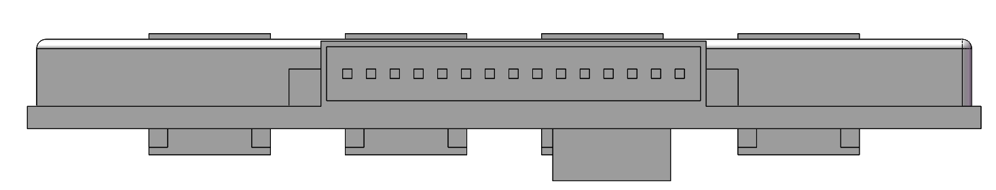
PIN1
No. | Symbol | Comment
1 | GND | Ground
2 | GND | Ground
3 | VCC | Power Supply
4 | VCC | Power Supply
5 | GPO1 | General output (3.3V TTL level)
6 | GPO2 | General output (3.3V TTL level)
7 | GPI1 | General input (3.3V TTL level)
8 | BUZZER | Buzzer driver output, high level effective. Current sourcing over 50mA
9 | RXD | Serial data input
10 | TXD | Serial data output
11 | USB-DM | For test only
12 | USB-DP | For test only
13 | GPI2 | General input (3.3V TTL level)
14 | EN | Enable. High level effective with internal 10kOhm resistor pulled up to VCC
15 | RS485_CTRL | RS-485 direction control

- Antenna Interface

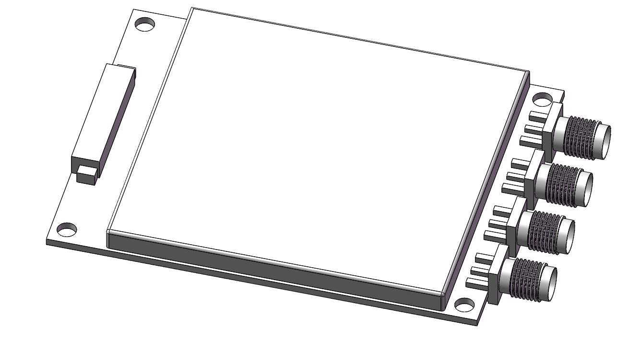
ANT1
ANT2
ANT3
ANT4
1
SMA Antenna Socket

Application Information
- When designing fixed reader with CF-MU804, please take care of heat sinking and remember to make sure the heat sinker of the module is closely and stably attached to the reader’s bottom plate;
- ANT1 is the default antenna port. Please pay attention to antenna port’s definition.
- Please refer to user’s manual for detailed protocol description.

